

Subscribe to DeepL Pro to edit this document.  
Visit [www.DeepL.com/pro](https://www.deepl.com/pro?cta=edit-document) for more information.

|  |  |
| --- | --- |
|  |  |



|  |  |  |
| --- | --- | --- |
| **Box** | : | TAOR7 / TWHF010 / TWH006 (Operations Research 7) |
| **Type of examination** | : | Regular |
| **Date** | : | Tuesday, April 20, 2021 |
| **Time** | : | 09:00 - 10:30 without TTV,  (09:00 - 11:00 with TTV) |
| **Training** | : | Applied Mathematics |
| **Form** | : | Full-time |
| **Class(es)** | : | T2A & T2B (cohort 2019), plus retakes from previous cohorts |
| **Teacher(s).** | : | WILR, VERC |
| **Keys** | : | WILR |
| **Key screened by** | : | VERC, April 7, 2021 |
| **Number of assignment sheets** | : | 5 pages of test questions, 2 answer sheets  (Plus: this cover sheet and sheet with other comments and blank page;  so 10 pages total) |

|  |  |  |
| --- | --- | --- |
| **Resource data** |  |  |
| Paper  Books  Dictates | :  :  : | Yes, namely: draft paper/line paper/check paper  No  No |
| Calculator | : | **Laptop with Windows To Go stick** |
| Formula sheet/own annotation | : | No |
| Other learning resources | : | No |

|  |  |  |  |  |  |  |  |  |  |  |  |  |  |  |  |  |  |  |
| --- | --- | --- | --- | --- | --- | --- | --- | --- | --- | --- | --- | --- | --- | --- | --- | --- | --- | --- |
| **Rating the tasks** | | | | | | : |  | |  | | | | | | | | | |
| Question | 1 | 2 | 3 | 4 | 5 | | | 6a | | 6b | 6c | 7a | 7b | 8a | 8b | 8c | 9 | 10 |
| Points | 3 | 1 | 2 | 2 | 3 | | | 2 | | 2 | 2 | 2 | 2 | 3 | 1 | 1 | 1 | 2 |
| Final grade determination | | | | | | : |  | |  | | | | | | | | | |

|  |
| --- |
| **The general conditions of the examination regulations apply to this examination** |

|  |
| --- |
| **Other comments are on the next sheet** |

|  |
| --- |
| **Please include your name, class and student number on all sheets to be turned in!** |

|  |
| --- |
| **Turn in exam papers after exam: Yes**  **Afterwards, hand in ALL: all the paper, the exam and the stick**  **(if yes, to be checked by the invigilator)** |

|  |
| --- |
| **Other comments:**  Fill in the answers to **Problem 8a and 8b** on the answer sheet. The answer sheet is on the last pages in duplicate. Make sure you have written your name and student number on these answer sheets.    For the other assignments: Substantiate your answer and submit all answers and corresponding justifications on exam paper, labeled with your name and student number.  A zip file CITB.zip accompanies this exam. This zip file contains the AIMMS model to **Problem 7**. You can download this zip file from the location  http://toetsing.flotwiskunde.nl/OR7/CITB.zip  You are allowed to use utilities such as Python, Matlab or AIMMS. The results found from these calculations cannot be used to support your answer and are for personal verification only.  You do not need to submit digital files. |

**Problem 1 [3pt]**

Given is the following linear programming problem:

$$\begin{matrix}\text{min} & -9w_{1}+4w_{2}+16w_{3}-11w_{4} & \\ \text{s.t.} & w_{1}+w_{2}+w_{3}+w_{4} & =100 \\ & 2w_{1}-w_{2}+4w_{3}-2w_{4} & ≤200 \\ & w_{1}≥0,w_{2}≤0 & \end{matrix}$$

Convert the problem to an LP in standard form. Of the LP in standard form, give the solution vector $w,$ the cost coefficient vector $c$**,** the coefficient matrix $A$ and the right hand vector $b$.

**Problem 2 [1 pt]**

Describe in your own words why the simplex method is an exact solution method for solving a linear programming problem.

**Problem 3 [2pt]**

On the linear programming problem

$$\begin{matrix}\text{max} & 3x_{1}+6x_{2} & \\ \text{s.t}. & x_{1}+x_{2} & ≤2 \\ & x_{1}+x_{2} & ≥3 \\ & x_{1},x_{2}≥0 & \end{matrix}$$

the two-phase *simplex* search method is used. (You do not have to perform this calculation yourself!)

Indicate by justification whether the two-phase simplex method already stops immediately after Phase 1 or not until Phase 2.

**Problem 4 [2pt]**

On a linear programming problem, the simplex method is applied. Below you can see what the table form looks like immediately after initialization:

|  |  |  |  |  |  |
| --- | --- | --- | --- | --- | --- |
|  | $$x_{1}$$ | $$x_{2}$$ | $$x_{3}$$ | $$x_{4}$$ |  |
| $$\max{c}$$ | $$10$$ | $$1$$ | $$0$$ | $$0$$ | $$b$$ |
| $$A$$ | $$-1$$ | $$1$$ | $$4$$ | $$21$$ | $$13$$ |
|  | $$2$$ | $$6$$ | $$0$$ | $$-2$$ | $$2$$ |
| $$t=0$$ | $$B$$ | $$N$$ | $$B$$ | $$N$$ |  |

Provide the initial base solution associated with this table form $x^{(0)}$ and costs $c⋅x^{(0)}$.

**Problem 5 [3pt]**

Consider the following linear programming problem:

$$\begin{matrix}\text{max } & 14x_{1}+7x_{2} & & \\ \text{s.t.} & 2x_{1}+5x_{2} & ≤14 & (1) \\ & 5x_{1}+2x_{2} & ≤14 & (2) \\ & x_{1},x_{2}≥0 & & \end{matrix}$$

The optimum 42 is realized in the point $\left(x_{1}^{*},x_{2}^{*}\right)=(2,2)$.

Based on a detailed calculation on paper, give the shadow price (*shadow price*) of the first constraint $(1)$.

**Problem 6 [2pt + 2pt + 2pt]**

A major university sports tournament will soon be organized in Eindhoven. For this tournament, 25,000 tickets can be made available to three different visitor groups: the media, people connected to the participating universities and the general public. The media do not have to pay an entrance fee, and the entrance fees for universities and the public are 5 euros and 12.50 euros per ticket, respectively. The organization wants to maximize total ticket revenue.

At least 500 tickets must be allocated to the media. The number of tickets sold to the other public is at most double the number of tickets for universities.

Let $I≜\{1:\text{media}, 2:\text{universiteiten}, 3:\text{overig}\}$ be the visitor groups, and $x_{i}≜$ the number of visitor group $i∈I$ assigned tickets. Then the above problem can be modeled as the following linear programming problem:

$$\begin{matrix}\text{max} & 5x_{2}+12.5x_{3} & & \text{"ticketopbrengst"} \\ \text{s.t.} & x_{1}+x_{2}+x_{3} & ≤25000 & \text{"beschikbaar aantal tickets"} \\ & x_{1} & ≥500 & \text{"voldoende tickets media"} \\ & 2x_{2}-x_{3} & ≥0 & \text{"niet teveel tickets overig"} \\ & x_{1},x_{2}x_{3}≥0 & & \end{matrix}$$

The problem has been solved in AIMMS. Moreover, a sensitivity analysis was performed. The following figure shows the report associated with this analysis (*solution listing*).

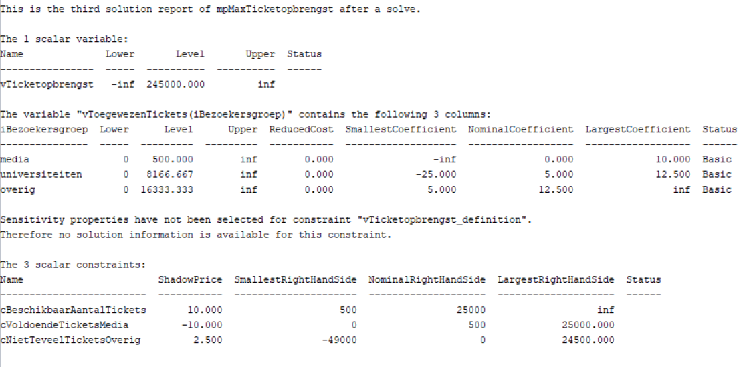To answer questions a through c), use the report as best you can.

1. What ticket revenue can be realized if 30,000 tickets are available?
2. How high will ticket revenue be if the ticket price for the rest of the audience is 10 euros?
3. The organization wants the proportion of tickets going to the media not to be too high. A maximum of one media representative for every 20 university visitors is being considered. Will this change the optimal ticket allocation?

**Problem 7 [2pt + 2pt]**

Given is the following math program with two objectives (*multiobjective ILP)*:

$$\begin{matrix}\text{min} & f\left(x\right)=1.0x_{1}+0.4x_{2}+1.4x_{3}+1.8x_{4}+2.0x_{5} & \\ \text{min} & g\left(x\right)=2.5x_{1}+5.4x_{2}+4.6x_{3}+4.2x_{4}+14.4x_{5} & \\ \text{s.t.} & 24x_{1}+29x_{2}+45x_{3}+34x_{4}+80x_{5}≥85 & (1) \\ & x_{j}∈\left\{0,1\right\} j=1,…,5 & \end{matrix}$$

This problem has two target functions ( $f(x)$ and $g(x)$) that must both be minimized, while one boundary condition $(1)$ must be satisfied. The first goal function, $f$ is the most important.

The problem has already been declared in AIMMS, see CITB.zip. Using AIMMS, compute the solution to this multiobjective ILP using lexicographic optimization (*preemptive optimization*).

1. Give the two *math programs* that are solved successively in AIMMS. You may concisely write down the math programs by means of the function names and reference to boundary condition $(1)$.
2. Give the *preemptive* solution $x^{*}$ for the multiobjective ILP, i.e., the values $x^{*}=(x_{1}^{*}, …., x_{5}^{*})$, $f(x^{*})$ and $g(x^{*})$.

**Problem 8 [3pt + 1pt + 1pt]**

In Figure 1 a network of 6 nodes is given: *source $(so), 1, 2, 3, 4$*  and *sink $(si)$* . The integers near the arrows indicate the capacities of the arrow: over the arrow $(so,1$) three units can flow.

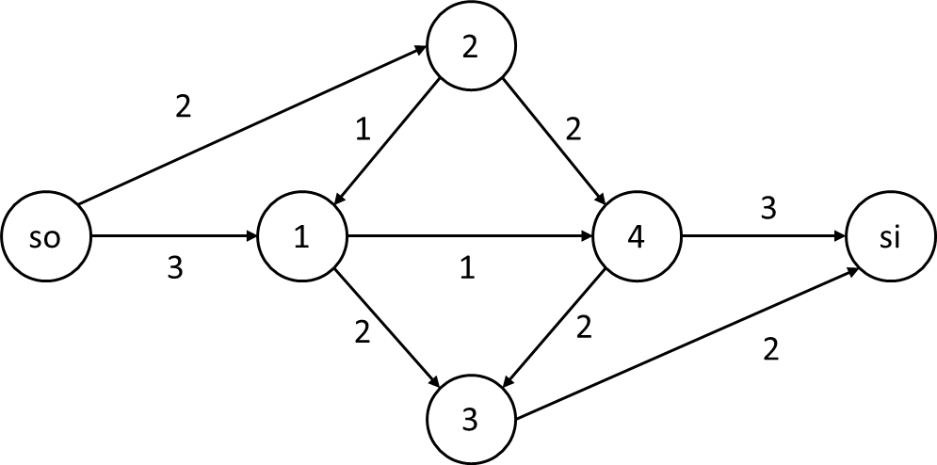

Figure 1 : Network of six nodes, with given capacities

In Figure 2 an allowable flow (*feasible flow*) the size of 3 units through the network is plotted.

|  |  |  |  |  |  |  |  |  |  |  |  |  |  |  |  |  |  |  |  |  |  |  |  |  |  |
| --- | --- | --- | --- | --- | --- | --- | --- | --- | --- | --- | --- | --- | --- | --- | --- | --- | --- | --- | --- | --- | --- | --- | --- | --- | --- |
| Figure 2 : Permitted current in network | |  |  |  | | --- | --- | --- | | Arrow | ***Current*** | Capacity | |  | ***1*** | 3 | |  | ***2*** | 2 | |  | ***1*** | 1 | |  | ***2*** | 2 | |  | ***2*** | 2 | |  | ***2*** | 2 | |  | ***1*** | 3 | |

1. **On the answer sheet,** draw the residual *graph* for this flow. Based on the residual graph, give a *flow* augmenting path from *source* to *sink*.
2. **On the answer sheet,** draw an allowable flow (*feasible flow*) from *source* to *sink* the size of 5 units.
3. Provide justification that an allowable flow equal to 5 units is a maximum flow.

**Problem 9 [1 pt]**

Describe in your own words what a path is in a given graph with points and arrows.

**Problem 10 [2 pt]**

When analyzing a project with a given deadline, you can use a project graph (*project network*) to gain insight into the schedule of all project activities. For example, there is a method that allows you to calculate the *earliest* possible start time for each project activity.

In doing so, describe in your own words how you can determine for each project activity whether it can start later than this earliest possible time.

(This is the end of the test, followed by the answer sheets).

# Answer Sheet for Problem 8

|  |  |  |  |
| --- | --- | --- | --- |
| Name |  | Student number |  |

|  |  |
| --- | --- |
| Figure 1 | Figure 2 |

**Problem 8a)**

Draw the residual count below.

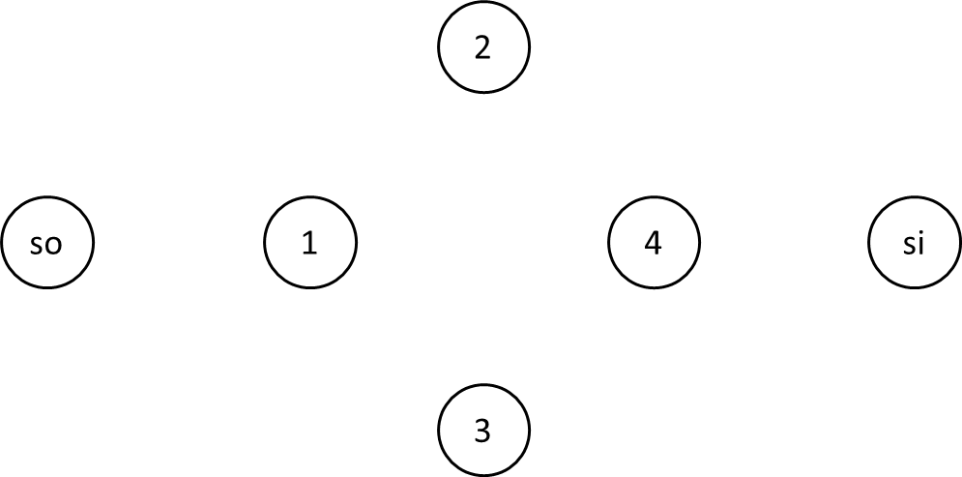

|  |  |
| --- | --- |
| Flow multiplying path = |  |

**Problem 8b)**

Draw below an allowed flow from *source* to *sink* the size of 5.

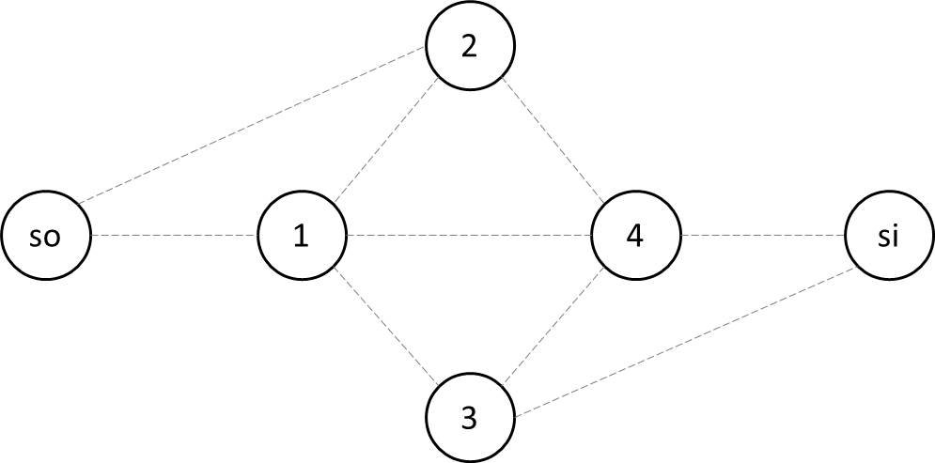

# Answer Sheet for Problem 8 (Copy).

|  |  |  |  |
| --- | --- | --- | --- |
| Name |  | Student number |  |

|  |  |
| --- | --- |
| Figure 1 | Figure 2 |

**Problem 8a)**

Draw the residual count below.



|  |  |
| --- | --- |
| Flow multiplying path = |  |

**Problem 8b)**

Draw below an allowed flow from *source* to *sink* the size of 5.

